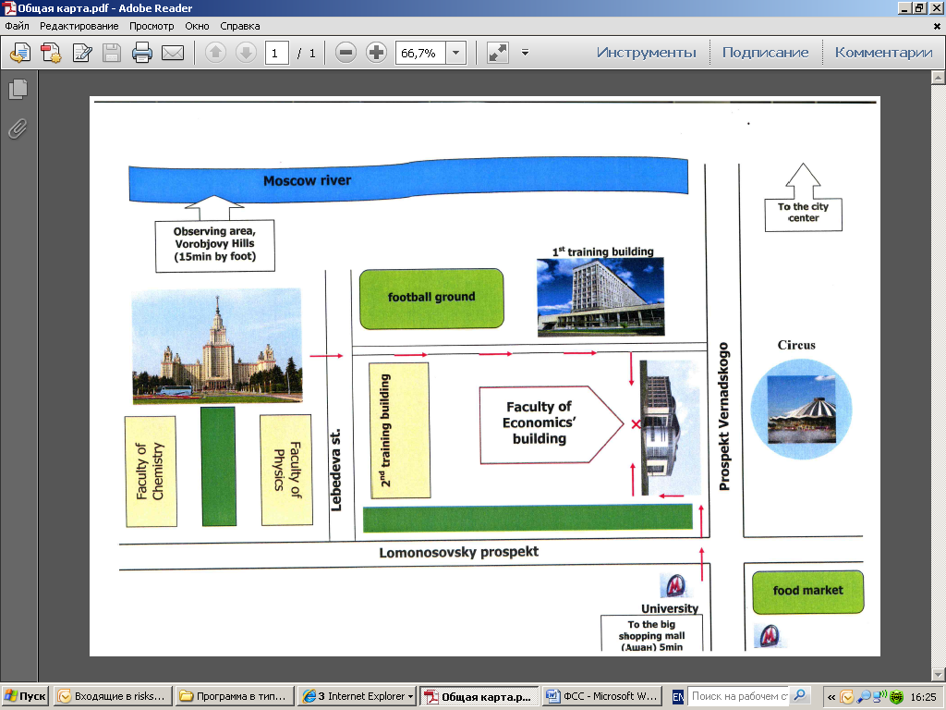

**SECTOR "Е"-HOTEL**

**Bookstore**

**Dining-rooms**

**MSU medical center**

**MSU main library building**

**History museum of MSU**

**Science library**

**Polyclinic №202, pharmacy**

**Chemist's shop**

**Bank**

**Post**